

|  |  |  |  |  |  |  |
| --- | --- | --- | --- | --- | --- | --- |
| Pizza’s | | Contour van hele pizza | | | Drinken |  |
| Margherita …………………………  Pomodoro, verse mozzarella, basilicum, Grana Padano   * Medium, large, calzone | **€ 9,50** | |  | **7up ……………………………………**  **Cola …………………………………..** | | € 3,00  € 3,00 |
| Quattro formaggio ………………..  Extra vierge olijfolie, gerookte mozzarella, verse mozzarella, gorgonzola, Grana Padano, basilicum   * Medium, large, calzone | **€ 10,00** | |  | Cola light …………………………….  Sinas …………………………………. | | € 2,50  € 3,00 |
| Salami ………………………………  Marinara, mozzarella, pepperoni   * Medium, large, calzone | **€ 8,00** | |  | Milkshake vanille …………………... | | € 3,50 |
| Vegetariano ………………………..  Champignons, mozzarella, zwarte olijven, groene en rode peper, ui, oregano   * Medium, large, calzone | **€ 9,00** | |  | Milkshake choco ……………………. | | € 3,50 |
| Pollo ………………………………...  Kipblokjes, champignons en mozzarella   * Medium, large, calzone | **€ 10,50** | |  | Milkshake aardbei …………………. | | € 3,50 |
| Shoarma ……………………………  Tomatensaus, mozzarella, shoarma, knoflooksaus   * Medium, large, calzone | **€ 9,50** | |  | Chocomelk …………………………..  Fristi …………………………………. | | € 2,00  € 2,00 |
| Sopranos Deluxe …………………..  Rundvlees, worst, pepperoni, uien, zwarte olijven, champignons, mozzarella   * Medium, large, calzone | **€ 10,00** | |  | Appelsap …………………………….. | | € 2,00 |
| Bolognese …………………………..  Tomaten, gekruid rundergehakt, mozzarella, Edammer kaas   * Medium, large, calzone | **€ 8,00** | |  | Red bull ……………………………… | | € 2,50 |
| Tonno ……………………………….  Passata, mozzarella, tonijn, rode ui   * Medium, large, calzone | **€ 9,00** | |  |  | |  |
| Hawaï ..……………………….........  Mozzarella, gerookte ham, ananas   * Medium, large, calzone | **€ 9,50** | |  |  | |  |
| * Kies een formaat   medium pizza (25 cm)  large pizza (35 cm)  calzone (opgevouwen pizza) |  | |  |  | |  |

Soprano’s Pizza



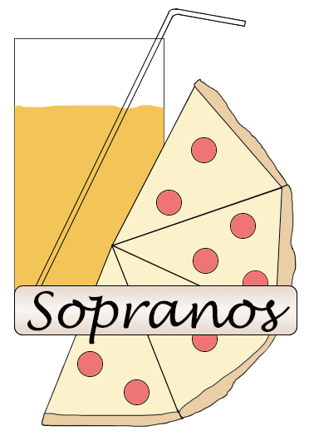Soprano’s Pizza